**CURRICULUM VITAE**

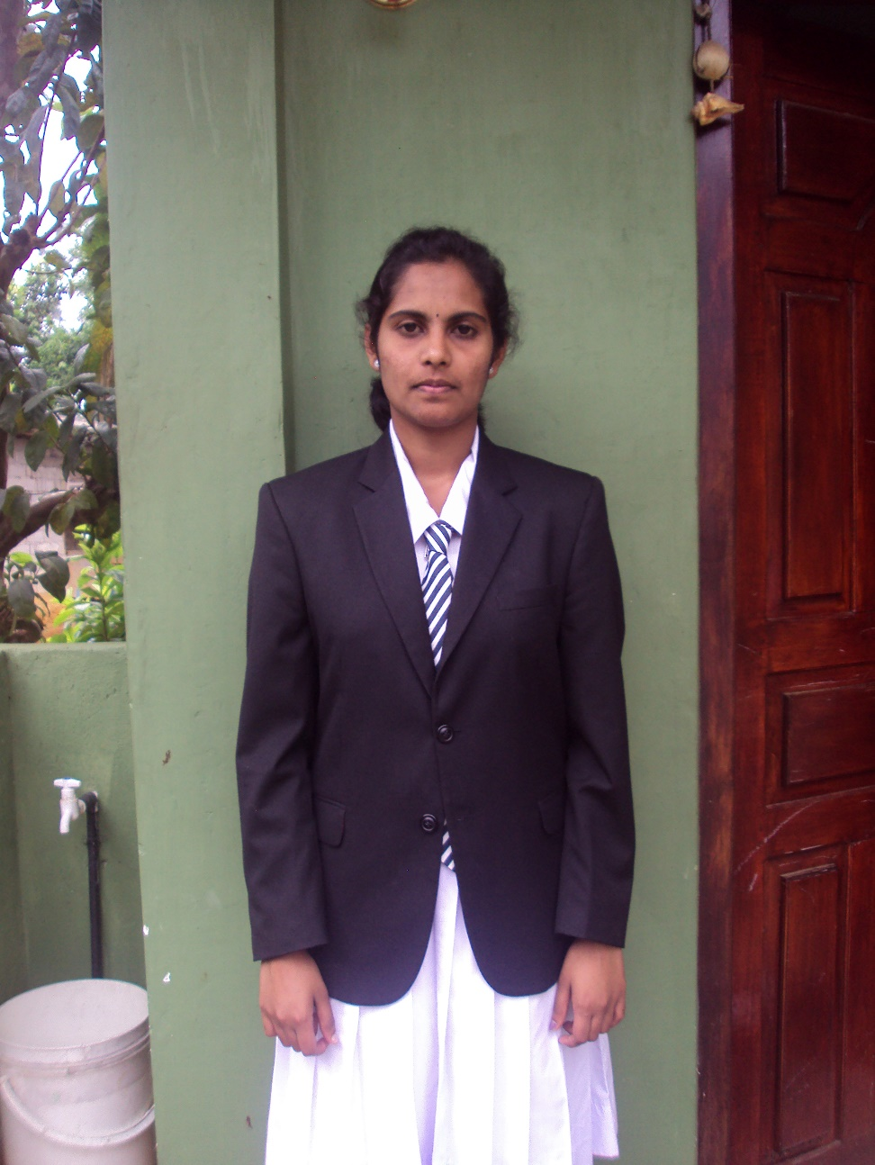V.Sri Ramesh Nehru,

No- 54/1,

Wholfendal Street.

Colombo 13.

Mob :0778189777, 0770758761.

Email :sri03ramana@gmail.com

**Objective**

Being trust worthy and obedient to the superiors and I assure my deep interest in accounting field. Willing to work in challenging environment to achieve the higher levels with hard work and courage.

**Personal profile**

* Name in full : Veerappan Sri Ramesh Nehru
* Date of birth : 1988 feb 12
* Sex : Male
* Nationality : Srilankan
* N.I.C. No. : 883401420v
* Civil status : Single
* School attended : Saraswathi Centrel Collage, Badulla.
* Resident contact : 0555618338

**Educational Qualifications**

* G.C.E. Ordinary level examination (Tamil medium) in 2004

|  |  |  |
| --- | --- | --- |
| Subject | | Grade |
| Tamil | | B |
| Health Science | | B |
| Religion | | B |
| Commerce | | C |
| Social Study | | C |
| Science | | C |
| Mathematics | | C |
| English | | S |
| Tamil literature | | S |
| Arts | S | |

* G.C.E. Advanced level examination (Tamil medium) in 2007

|  |  |
| --- | --- |
| Subject | Grade |
| Business studies | C |
| Economics | C |
|  |  |

**Other qualifications**

* I have Successfully completed the General Management Diploma Level. (English Medium)

**Languages**

* English, Tamil, Singhala

**Working Experience**

* I Have Worked at Azeez Brother Group of Company in Badulla as a branch Accountant.
* I Have Worked at SLR Holyday inn at Kalmunai as an Accounting Manager.
* I Have 5 years Experience in Auditing and Tax Consulting,
* I worked at **Bodyline,** As an Accountant From 2012 to 2015.
* I Have 9 Years experience in Book Keeping manual and Software system.
* Presently I working at infodata accounting solution system in Colombo.

**None related referees**

Mr.Nithiyananthan Mr.S.Amaranathan

Bodyline, No: 374,Colombo road,

No:118A Keyzer Street, Bandarawela.

Colombo 11.

Tel: 0777634089 Tel: 0773864262

I do hereby certify that the given above particulars stated by me are true and accurate to the best of my knowledge.

………………………………………… ………………………………………..

Signature Date